University of Science and Technology
- Wrocław-



LABORATORY 11: UTILIZING SOFTWARE TO ESTIMATE THE TOTAL COST OF SOFTWARE ACQUISITION AND MAINTENANCE

SUPPORT FOR IT PROJECT MANAGEMENT
2025/2026
Teacher: Piotr Zabawa
Student: Álvaro Puebla Ruisánchez 293867

Table of Contents
Table of Contents 2
1. Software Overview 3
1.1 Name and Purpose 3
1.2 Key Functionality 3
1.3 Why Google Sheets Was Selected 3
2. Performed Tasks 5
2.1 Task 1 - Building the Main TCO Cost Table 5
2.2 Task 2 - Creating the Cost Classification Summary Table 6
2.3 Task 3 - Computing Multi-Year TCO Projections 7
3. Summary 8
3.1 Software Suitability Assessment 8
3.2 Evaluation of Software Functionality 8
3.3 User Interface Evaluation 8
3.4 Evaluation of Other Software Attributes 9

1. Software Overview

1.1 Name and Purpose
The software used during Laboratory 11 is Google Sheets, a web-based spreadsheet application developed and maintained by Google LLC. Google Sheets is a cloud-native productivity tool that enables users to create, edit, and share structured data documents directly from a web browser without requiring any local installation. In the context of IT project management, Google Sheets serves as a practical platform for constructing quantitative decision-support models, including Total Cost of Ownership (TCO) estimations. TCO analysis is a critical activity for project managers, as it reveals the full lifecycle cost of a software solution - encompassing not only the initial purchase price but also recurring expenses such as maintenance, support, administration, and training. A dedicated and structured tool is necessary for this task because low acquisition prices do not always correspond to low long-term costs, and hidden expenses are frequently underestimated when decisions are made without a systematic framework. Google Sheets addresses this need by providing a familiar, formula-driven environment capable of capturing all relevant cost components, automating calculations, and presenting results in a stakeholder-friendly format.

1.2 Key Functionality
Google Sheets provides a comprehensive set of features that directly support TCO estimation workflows. Its core capability is the spreadsheet grid, which allows users to enter structured data across rows and columns representing individual cost items, cost types, quantities, and unit prices for multiple software alternatives. The application supports a rich formula language, including arithmetic expressions and conditional aggregation functions such as SUMIF, which enable automatic calculation of row totals, cost category subtotals, and multi-year lifecycle projections without manual arithmetic. Data validation controls, including dropdown menus, allow cost items to be classified consistently as either Acquisition or Maintenance costs, reducing input errors and ensuring uniform categorisation across the dataset. Google Sheets also supports charting functionality, through which numerical summary results can be rendered as bar charts or other visual formats suitable for stakeholder communication. Collaboration features - including real-time sharing via links, granular access permissions (view, comment, or edit), and a full version history - ensure that the working file can be reviewed, audited, and updated by multiple stakeholders. The application is accessible at no cost for personal Google accounts and requires only a browser to operate, with no installation overhead.

1.3 Why Google Sheets Was Selected
Google Sheets was selected as the tool for this laboratory exercise following a structured comparative analysis of four candidate applications: Google Sheets, Microsoft Excel, Smartsheet, and Airtable. The selection was guided by a MoSCoW-prioritised set of functional requirements derived from project manager needs, including cost item entry, formula-based calculation, cost type classification, multi-year TCO computation, editable assumptions, summary visualisation, and sharing or export capability. A suitability matrix was used to evaluate each tool against these criteria. Google Sheets and Microsoft Excel both achieved a "Good" rating across all seven criteria, while Smartsheet received "Medium" ratings on formula calculation, multi-year TCO, and editable assumptions, and Airtable received "Weak" ratings on multi-year TCO and editable assumptions. Google Sheets was ultimately preferred over Excel due to its zero-cost accessibility for personal accounts, its browser-only operation requiring no software installation, and its native real-time collaboration model. These attributes make it the most inclusive and practically convenient tool for an academic laboratory setting where students work across different devices and operating systems.

2. Performed Tasks

2.1 Task 1 - Building the Main TCO Cost Table
Task description:
The first task consisted of creating a new Google Sheets document and constructing the primary data entry table for the TCO comparison. The process began by opening a web browser and navigating to sheets.new in the address bar, which immediately created a blank spreadsheet under the signed-in Google account. The file was renamed to "Lab11" using the title field at the top of the interface, and the active sheet tab was renamed to "TCO" to clearly identify the worksheet's purpose. A header row was then entered in row 1, containing the following seven column labels: Item, Type, Quantity, Unit cost A, Total A, Unit cost B, and Total B. These columns correspond to the cost item name, its classification (Acquisition or Maintenance), the number of units or licences involved, the per-unit cost for each of the two candidate software options being compared, and the calculated row total for each option. Six cost items were entered into rows 2 through 7, representing realistic software lifecycle cost components: Subscription licenses, Vendor support, Admin effort, Setup/configuration, Migration/import, and Initial training.
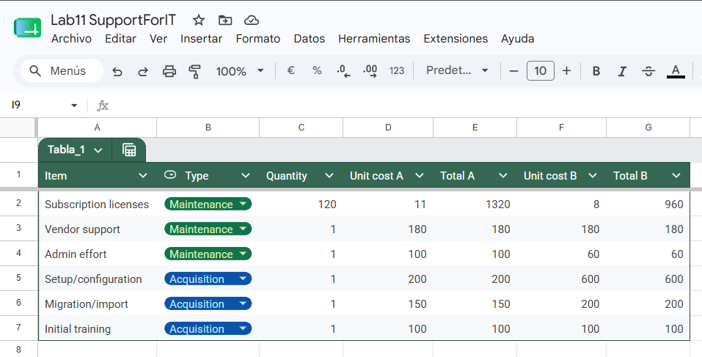
A dropdown validation list was applied to the entire Type column (cells B2 through B7) by selecting that range, opening the Insert menu, choosing Dropdown, and specifying the two permitted values: "Acquisition" and "Maintenance". This ensures consistent and error-free classification of each cost item. Finally, the row total formulas were entered: for Option A, the formula =C2D2 was entered in cell E2 and copied down to E7; for Option B, the formula =C2F2 was entered in cell G2 and copied down to G7. These formulas automatically compute the total cost for each line item by multiplying quantity by the respective unit cost. [1]
Figure 1. Screenshot of the completed main TCO data entry table, showing all six cost items with their types selected from the dropdown, quantities, unit costs for Options A and B, and automatically calculated row totals in columns E and G.

2.2 Task 2 - Creating the Cost Classification Summary Table
Task description:
The second task required the construction of a secondary summary table that aggregates all cost items by their type classification, producing subtotals for Acquisition costs and Maintenance costs separately for each software option. This table was placed below the main data table on the same TCO sheet, beginning at approximately row 10. The summary table was structured with three columns: Type, Total A, and Total B, with two data rows: one for "Acquisition" and one for "Maintenance". To populate the Total A column, the SUMIF function was used, which scans the Type column of the main table and sums only those row totals that match the specified category. The formula entered in the Total A cell for Acquisition was =SUMIF(Tabla_1[Type];"Acquisition";Tabla_1[Total A]), and the corresponding formula for Maintenance was =SUMIF(Tabla_1[Type];"Maintenance";Tabla_1[Total A]).
Equivalent formulas referencing column G were used for Option B. The SUMIF approach is important because it makes the summary table dynamically responsive to any changes in the main table: if a cost item's type is changed via the dropdown, or if a unit cost value is updated, both the row totals and the classification subtotals recalculate automatically without any manual intervention. The resulting summary confirmed the following subtotals: for Option A, Acquisition total = 450 and annual Maintenance total = 1,600; for Option B, Acquisition total = 900 and annual Maintenance total = 1,200. This separation is essential for the TCO formula, as acquisition costs are incurred once while maintenance costs recur annually over the full lifecycle period.
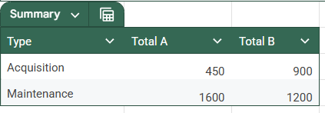
Figure 2. Screenshot of the cost classification summary table, showing SUMIF formulas in the formula bar and the computed Acquisition and Maintenance subtotals for both Option A and Option B.

2.3 Task 3 - Computing Multi-Year TCO Projections
Task description:
The third and final task involved creating a multi-year TCO projection table that applies the fundamental TCO formula - TCO = Acquisition total + (Number of years × Annual Maintenance total) - across three distinct time horizons. The table was placed below the classification summary table and structured with three columns: Number of years, Total A, and Total B. Three rows were added for time periods of 1 year, 5 years, and 10 years. The formulas in the Total A and Total B columns referenced the Acquisition and Maintenance subtotals computed in the Task 2 summary table, so that any upstream changes would automatically propagate through to the final projections as well. For Option A at 1 year: TCO = 450 + 1 × 1,600 = 2,050. For Option A at 5 years: TCO = 450 + 5 × 1,600 = 8,450. For Option A at 10 years: TCO = 450 + 10 × 1,600 = 16,450. For Option B at 1 year: TCO = 900 + 1 × 1,200 = 2,100. For Option B at 5 years: TCO = 900 + 5 × 1,200 = 6,900. For Option B at 10 years: TCO = 900 + 10 × 1,200 = 12,900. The projection table clearly demonstrates that while Option B has a higher one-time acquisition cost (900 vs. 450), its lower annual maintenance total (1,200 vs. 1,600) results in a progressively lower TCO as the time horizon extends. By year 3, the 3-year TCO for Option A is 5,250 and for Option B is 4,500, making Option B the more cost-effective choice over any period beyond approximately one year. To complete the exercise, a bar chart was inserted by selecting the summary data and choosing Insert > Chart, selecting a column chart type, and configuring the series to display the 3-year TCO values for both options side by side, with Option A rendered in orange and Option B in teal. This visual representation enables immediate communication of the cost differential to stakeholders without requiring them to interpret raw figures.
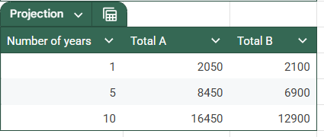
Figure 3. Screenshot of the multi-year TCO projection table and the accompanying bar chart, showing the 3-year TCO values of 5,250 for Option A and 4,500 for Option B visualised as a comparative column chart.

3. Summary

3.1 Software Suitability Assessment
Google Sheets is highly suitable for performing Total Cost of Ownership estimations in an IT project management context. The application directly supports all four Must-have requirements identified in the functional specification: structured cost item entry, formula-based automatic calculation, classification of costs as Acquisition or Maintenance, and computation of multi-year lifecycle totals. It also satisfies the two Should-have requirements - editable assumptions with automatic recalculation, and a summary view through charting - and the single Could-have requirement of sharing and export. The tool's design as a general-purpose spreadsheet means it imposes no rigid workflow on the user, allowing the TCO model to be adapted freely to different cost structures, numbers of alternatives, or evaluation periods. Compared to the other tools considered, Google Sheets stands out for its combination of zero entry cost, universal browser accessibility, and full formula power, which makes it the most appropriate choice for an academic setting and for early-stage project management analysis where dedicated TCO software may not be available or justified.

3.2 Evaluation of Software Functionality
The functionality of Google Sheets proved entirely adequate for the scope of the laboratory exercise. The formula engine handled all required calculations correctly, including multiplication for row totals, SUMIF-based conditional aggregation for cost category subtotals, and the multi-year TCO formula combining one-time and recurring costs. The dynamic recalculation behaviour - whereby any change to a unit cost, quantity, or dropdown classification immediately updates all dependent cells - is particularly valuable in a decision-support context, as it allows project managers to rapidly test alternative assumptions and observe their impact on the final TCO figures. The data validation dropdown feature effectively enforced consistent cost categorisation, which is a prerequisite for the SUMIF formulas to produce accurate results. The charting module provided a clear and professionally adequate bar chart for communicating results. One functional limitation worth noting is that Google Sheets does not provide built-in TCO-specific templates or domain terminology; the entire model structure must be constructed manually by the user, which requires a certain level of spreadsheet literacy and understanding of the TCO concept before the tool can be used productively.

3.3 User Interface Evaluation
The Google Sheets user interface is clean, intuitive, and consistent with widely recognised spreadsheet conventions established by tools such as Microsoft Excel, which means most users in an IT or business context will encounter a minimal learning curve. The grid-based layout, toolbar, formula bar, and sheet tabs are logically organised and respond predictably to user actions. The dropdown insertion workflow - accessed through the Insert menu - is straightforward, though slightly less discoverable than in some dedicated form-building tools. The charting wizard guides users through chart type selection and data range configuration in a step-by-step panel that is generally self-explanatory. Collaboration features are tightly integrated into the interface: the Share button is permanently visible in the top-right corner, and the version history is accessible via the File menu. On a standard desktop or laptop browser, the interface performs well without noticeable lag even when formulas recalculate across a full dataset. No significant usability issues were encountered during the exercise. The overall user experience supports efficient task completion and is appropriate for both novice and experienced users working on quantitative project management analysis.

3.4 Evaluation of Other Software Attributes
Several additional attributes of Google Sheets are relevant to its use in professional and academic TCO estimation workflows. With respect to performance, the application loads rapidly via the sheets.new shortcut and handles the scale of data used in this exercise - six cost items, multiple formula layers, and a chart - without any perceptible delay; for larger models with hundreds of cost items or complex cross-sheet references, performance remains acceptable in most cases. Accessibility is a strength of the platform, as it operates entirely in the browser on any operating system (Windows, macOS, Linux, ChromeOS) and requires no installation, which eliminates device-specific compatibility issues common in laboratory environments. The free-tier pricing model removes financial barriers for individual students and small teams. Data persistence is managed automatically through Google Drive, where all changes are saved in real time, eliminating the risk of data loss from unsaved files. Version history provides a meaningful audit trail for tracking changes to assumptions over time, which is relevant for transparent decision-making. The primary limitation of Google Sheets in this context is its lack of domain-specific TCO features: there are no built-in cost templates, no automated sensitivity analysis tools, and no structured reporting outputs beyond basic charts. Users who require advanced financial modelling, automated scenario comparison, or formatted executive-level reports would need to supplement Google Sheets with additional tooling or manual formatting effort. Nevertheless, for the purposes of structured TCO estimation as practised in this laboratory, the tool is well-matched to the task and represents a pragmatic, accessible, and effective choice.

